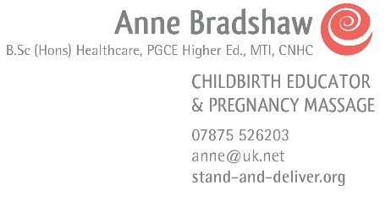

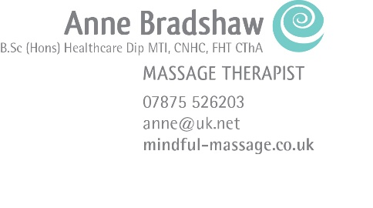

Privacy Policy
  - for Anne bradshaw,
  - massage therapist & childbirth/parenting consultant

  - mindful massage & stand and deliver

Privacy Statement
I will only use the information that I collect about you lawfully, in accordance with the General Data Protection Regulations (GDPR).

Who I am
I am Anne Bradshaw of Mindful Massage & Stand and Deliver Childbirth Education. I am a Massage & Bodywork Therapist and Childbirth Education Consultant, and these two occupations overlap with Pregnancy Massage, teaching Baby Massage and Baby Yoga and organizing Mother/Baby/Toddler group sessions. I am a self-employed sole proprietor.

I am a member (DATA CONTROLLER) of the ICO – the Information Commissioners office.

The General Data Protection (GDPR) which is EU wide and far more extensive than its predecessor the Data Protection Act, along with the Privacy and Electronic Communications Regulations (PECR), seek to protect and enhance the rights of EU data subjects. These rights cover the safeguarding of personal data, protection against the unlawful processing of personal data and the unrestricted movement of personal data within the EU and its storage within the EEA.

I comply with my obligations under the GDPR as a DATA PROCESSOR by keeping personal data up to date; by storing and destroying it securely; by not collecting or retaining any excessive amounts of data; by protecting personal data from loss, misuse, unauthorised access and disclosure and by ensuring that appropriate technical measures are in place to protect personal data.

Consent
By filling in any contact/medical information forms on my websites (www.mindful-massage.co.uk and www.stand-and-deliver.org) you are giving your consent for Anne Bradshaw to hold your personal information. The information which you supply on the forms will be held together with any clinical records or purchasing information, as applicable. I use your information to give you the best possible service and for insurance purposes.

When you arrive for an appointment with me, you will be asked for your written consent for me to keep your personal contact details, your health and medical information, and agreeing to the treatment I will be providing. Your written consent will also be needed to agree to me contacting you by e mail.

You can withdraw consent at any time by using the postal address, e mail address or telephone number provided at the end of this document.

Client Data
As a therapist it is necessary for me to hold both personal contact information and relevant health and medical data for my clients. I will only collect what is relevant and necessary for your treatment. After the treatment I will make notes concerning your treatment. This data is always held securely, is not shared with anyone not involved in your treatment unless I have your consent to discuss an issue with another health practitioners such a GP’s, Consultants, Physiotherapists and/or medical insurance companies. Where this is required we will always inform you first unless I am under a legal obligation to comply.

As a therapist I have to maintain the possibility of access to client data as a result of returning clients, or those who may wish to lodge a complaint in respect of my professional services either to my professional body or my insurers, possibly after a long period of time. Data is therefore retained for a minimum of 8 years. For any clients under the age of 18, data is retained until their 25th birthday.

Your contact details are retained so that you may be reminded of future appointments, and to provide you with other information relating to your treatment.

All data is held in the United Kingdom. I do not store personal data outside the EEA.

I hold this data under the heading of Vital Interests, being one of the 6 ICO Lawful Bases. I hold this data as it is of vital importance (interest) to me and my clients. Data is used to deliver the services that my clients have requested, to contact those clients as necessary, and to maintain accounts and records. With regard to Childbirth Education very little data is held apart from basic contact details, and these are held with consent and with legitimate interest.
Children’s Privacy
My Services do not address anyone under the age of 16. I do not knowingly collect personal identifiable information from children under 16. In the case I discover that a child under 16 has provided me with personal information, I immediately delete this from our servers. If you are a parent or guardian and you are aware that your child has provided me with personal information, please contact me so that I will be able to take any necessary actions.
Any client data relating to Baby Massage, Baby Yoga and Mother/Baby/Toddler Groups will be basic information for booking purposes, I do not collect data relating to children without the express permission of a parent or legal guardian. In practice, I only process the following information relating to children:
Childs Name
Date of birth
Medical history (if appropriate)
********
Third Party Service Providers
I use 10to8 as a provider for appointment bookings, and communications, together with Dropbox and Googlemail. Each of these providers has its own privacy and data protection policies in place (accessible via their websites).
Email marketing
With your consent I will send you emails about my practice, special offers, handy tips and other updates. You will need to positively opt in either online or on your initial consultation form to receive these updates. You can unsubscribe at any time, either through the ‘Unsubscribe’ button the emails or by emailing me at mindfulmasssageuk@gmail.com or writing to me direct at The Fold Therapy Centre, Bransford, Worcester WR6 5JB.

Links
If you click on links on my websites, they may direct you away from my sites. I am not responsible for the privacy practices of other sites and encourage you to read their privacy statements.

Use of Cookies
A cookie is a small piece of information which is automatically created by my websites on your computer. Please note that cookies are harmless to your computer. Cookies are a useful way of remembering the choices you have previously made while visiting my websites. If you do not wish me to use cookies when you use my websites, you can adjust your internet browser settings not to accept cookies. Your webs browser’s help function should tell you how to do this. Alternatively you can find information about how to do this for all the commonly used internet browsers on the website: https://www.aboutcookies.org/default.aspx. This website will also explain how you can delete cookies which are already stored on your device.

Please note that if you set your computer not to accept cookies, there may be certain features/areas on my websites that you may not be able to use.

Storing your information
Your information is stored both on an encrypted computer, or a locked filing cabinet. I do not use USB’s. If files are transported to an appointment these will be in a locked computer bag. All devices such as IPad and IPhone, and laptop computers are password protected. Any information held on a computer is backed up to Dropbox automatically.

Your Rights under GDPR
- Right of Access – you have the right to request a copy of the information that I hold about you.
- Right of Rectification – you have a right to correct data that I hold about you that is inaccurate or incomplete.
- Right to be forgotten – in certain circumstances you can ask for the data I hold about you to be erased from my records. This is subject to any obligations I have which may override this such as legal obligations to maintain records or for insurance purposes.
- Right to restriction of processing – where certain conditions apply you have a right to restrict the processing.
- Right of portability – you have the right to have the data I hold about you transferred to another organisation.
- Right to object – you have the right to object to certain types of processing such as direct marketing.
- Right to object to automated processing, including profiling – you also have the right not to be subject to the legal effects of automated processing or profiling.

Access of Personal Data
I will accept the following forms of identification (ID) when information on your personal data is requested: a copy of your driving licence, passport, birth certificate and a utility bill not older than three months. A minimum of one piece of photographic ID listed above and a supporting document is required. Requests should be made in the first instance in writing or by e mail.

Complaints
If you are unhappy with how I am handling your data, please raise your concerns with me first, so that we can seek a resolution. If you are still not satisfied, then you have the right to complain to the Information Commissioner’s Office (ICO). The ICO may be contact via its website which ishttps://ico.org.uk/concerns/, by live chat or by calling their helpline on 0303 123 1113.

Contact Details
Anne Bradshaw, Mindful Massage/Stand and Deliver 07875 526203
mindfulmassageuk@gmail.com

April 2019

